Taking hygiene up a level

Touch-free urinal flushing technologies from Viega

Attendorn, 14 August 2020 – The right combination is key: to meet the demand for best possible hygiene, urinals in public sanitary facilities must be designed in combination with touch-free flushing solutions. Viega offers two different touch-free flushing technologies. One is a concealed flushing solution and the other is controlled by infrared technology.

In public sanitary facilities, urinals are almost a matter of course, as they offer hygienic benefits for both operators and users. However, in order to provide a fully rounded solution, urinals also need to offer touch-free flushing technology. Viega offers two touch-free flushing technologies. As well as taking hygiene up a level and featuring a wide range of design options, they also provide protection against vandalism, support various optional flushing settings and are very easy to clean.

The concealed flushing solution

For the concealed flushing solution, neither a flush plate nor a cover plate is visible on the wall. Instead, a sensor installed inside the urinal siphon registers the changes in flow and temperature that occur whilst the urinal is in use and subsequently triggers flushing automatically. This technology can be relied upon to work unseen and delivers optimum hygiene and cleanliness combined with maximum protection against vandalism.

Alongside hygiene, usability is another important consideration for the operators of public sanitary facilities. Even here, concealed flushing scores points by offering three different flushing volume options depending on use. They include flushing with one or three litres, as well as a dynamic option, which automatically detects high use frequency and reduces the flushing volume from three litres to one. One example of high use frequency might be at half time during a football match or at the interval during a concert. Flushing frequency is then also limited to one activation per minute. Depending on the selected setting, additional hygiene flushing can also be triggered automatically after 24 hours.

A practical diagnostic function can also detect faults and respond accordingly. Flushing is triggered automatically if a blockage in the siphon is preventing the urinal from flushing, for example, or if the water level in the siphon is too low.

Viega's concealed flushing solution is available as an equipment kit. It is compatible with the corresponding version of the Viega Prevista Dry urinal element.

Flushing solution using infrared technology

Thanks to an infrared sensor in the flush plate, this flushing option also delivers maximum hygiene by being touch-free. Standing in front of the detection range of the infrared sensor for at least eight seconds will always trigger flushing. Both the detection range and the flushing volume and duration can be adjusted in line with expected use and to meet individual requirements.

In the event of interruptions in use (such as those that might occur at certain times in schools or hotels), the preservation of drinking water quality becomes the top priority. To avoid stagnation in drinking water pipelines and prevent germ formation, the infrared flushing solution is fitted with Viega Hygiene technology. This enables flushing to be programmed very easily and then triggered at specific times.

The infrared technology is installed behind the wall together with the compatible Viega Prevista Dry urinal element. Once installed, only the flush plate (available in two different designs) with its integrated sensor is visible.

The Visign for More 200 IR urinal flush plate, for example, is available in wood stained oak, jet black or traffic white glass, as well as in various plastic options. It is the perfect complement to any sanitary facility design. Together with the Viega Visign for More 200 flush plate, for example, it provides the basis for harmonious interior design concepts in public spaces.

EN_PR_200814_Touch-free urinal flushing technologies.doc

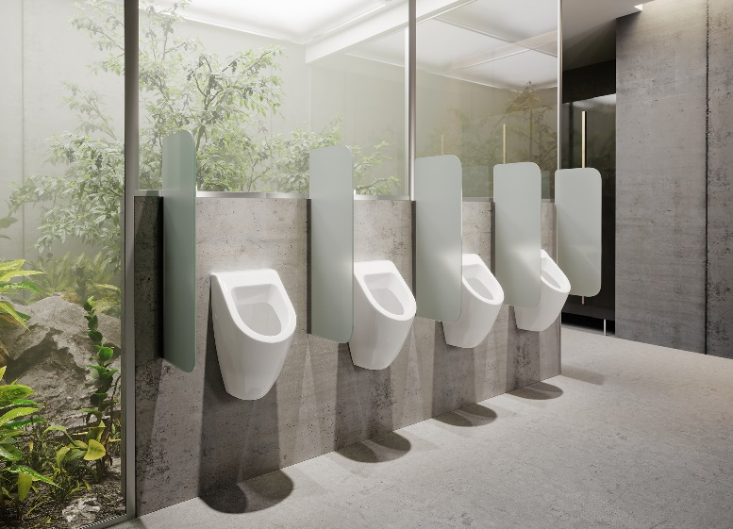
PR_200812_ beruehrungslose Spueltechniken Urinal_01.jpg
The concealed urinal flushing solution impresses with outstanding hygiene and absolute protection against vandalism. Flushing is triggered via a sensor installed inside the urinal siphon. A flushing technology for clear, stripped-back design concepts. (Photo: Viega)

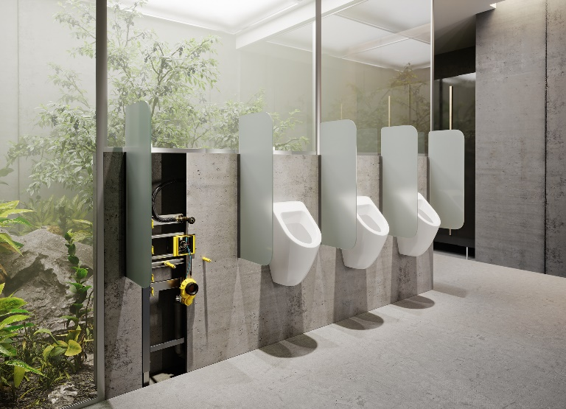
PR_200812_ beruehrungslose Spueltechniken Urinal_02.jpg
In the concealed flushing solution, the technology is hidden inside the urinal siphon. The sensor (yellow component at the bottom) registers the changes in flow and temperature that occur whilst the urinal is in use and triggers flushing automatically. (Photo: Viega)

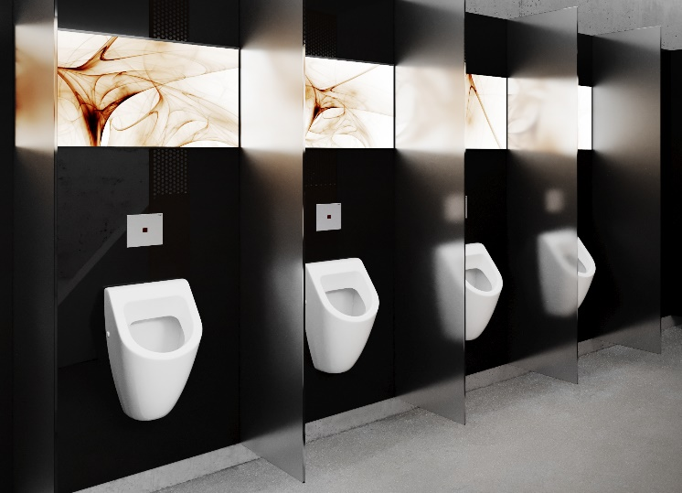
PR_200812_beruehrungslose Spueltechniken Urinal_03.jpg
Harmonious interior design concepts that take hygiene to the next level: Viega's infrared control urinal flush plates are the perfect complement to the design of the WC flush plates. Flushing is totally touch-free. (Photo: Viega)

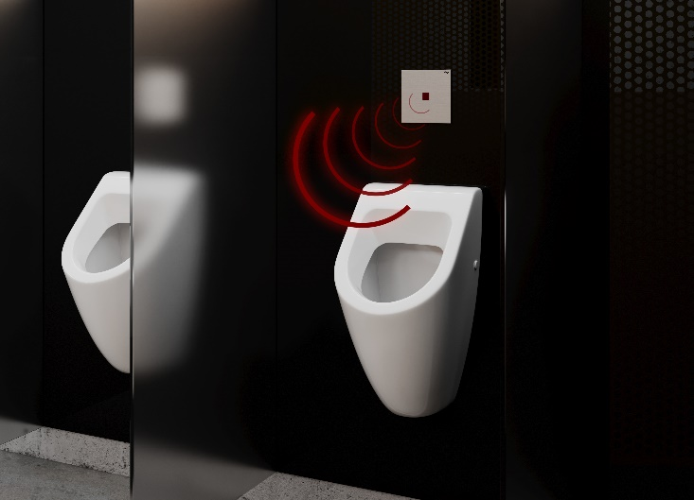
PR_200812_beruehrungslose Spueltechniken Urinal_04.jpg
Touch-free flushing is triggered by standing in front of the detection range of the infrared sensor for at least eight seconds. Both the detection range and the flushing volume and duration can be adjusted.
(Photo: Viega)

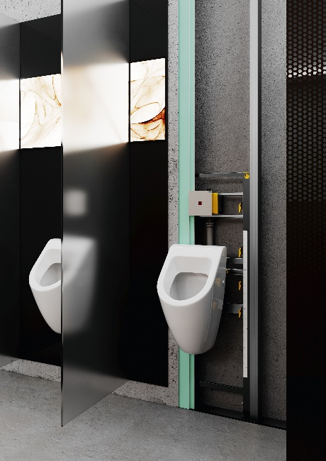
PR_200812_ beruehrungslose Spueltechniken Urinal_05.jpg
The infrared technology is installed behind the wall together with the compatible Viega Prevista Dry urinal element. (Photo: Viega)

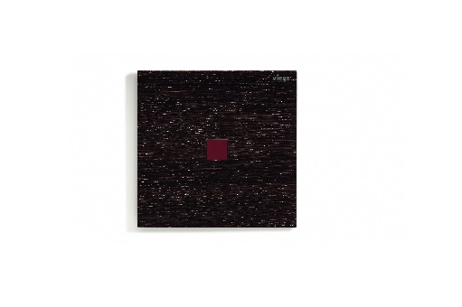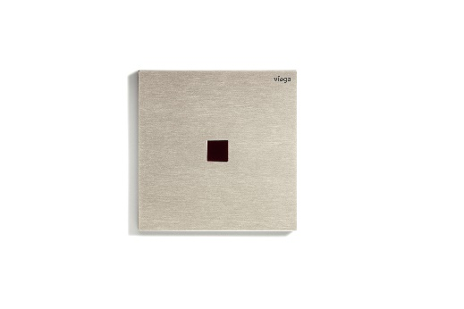

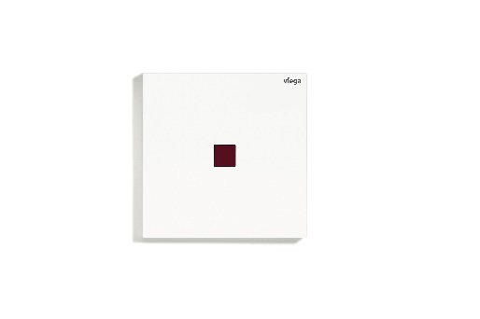
PR_200812_beruehrungslose Spueltechniken Urinal_06 to 09.jpg
Infrared technology never looked better: Viega's Visign for More 200 IR touch-free urinal flush plate is available in wood stained oak, jet black or traffic white glass, for example, as well as in various plastic options.
(Photo: Viega)

Technology meets design at Viega
It is not just the elegant look and multi-award-winning design of Viega’s Visign products that are constantly making waves in modern bathroom design – the sophisticated technology they use and supreme comfort they provide are also outstanding. Viega enables customers to create unique, modern bathrooms with a spa-like feel with its comprehensive range of products such as shower channels, WC actuator plates, bath fittings, electronic bath controls, plus pre-wall technology that is extremely flexible. Viega Prevista pairs comfort with design. Height-adjustable WC and washbasin modules, along with the selection of striking WC and urinal flush plates, ensure the new pre-wall range is a true all-rounder in the bathroom. A large selection of bath drains, floor drains and washbasin traps completes the range.

Colour-matched Viega products in exciting material compositions help customers to achieve coordinated bathroom design.

Viega Visign forms part of the pre-wall and drainage technology product range of the global Viega Group, which is one of the leading manufacturers of installation technology.

